Instructions for the daily inspection of the sorter
Note: All inspections need to be carried out after the power is turned off, do not operate with electricity!

1. Inspection of heat dissipation device and dust removal
The power supply, lighting source and other parts inside the optical sorter will generate heat during normal operation, and in order to ensure the normal operation of the optical sorter, these areas need to be cooled. Due to the large amount of dust in the air on site, in order to avoid the dust in the air from entering the equipment, the heat dissipation of the optical separator is completed through the heat dissipation box and the purification box.
- Dust the cooling box (cleaned once a week).
The heat dissipation box uses the internal air circulation heat dissipation mode, the outside air is not interchangeable with the internal air, and the heat exchange module can effectively reduce the temperature of the internal air after the heat exchange module exchanges the internal and external air. In order to ensure the efficiency of heat exchange, it is necessary to carry out regular dust removal and maintenance of the equipment. The procedure is as follows:
First of all, use an air gun to clean the dust of the heat exchange module of the heat dissipation box, then open the cover plate of the heat dissipation box, and use the air gun to clean the dust on the fan page of the cooling fan; finally observe the state of the heat dissipation fan motor, check whether there is any abnormal noise caused by debris, etc., if necessary, it is necessary to remove dust or add lubricating oil.
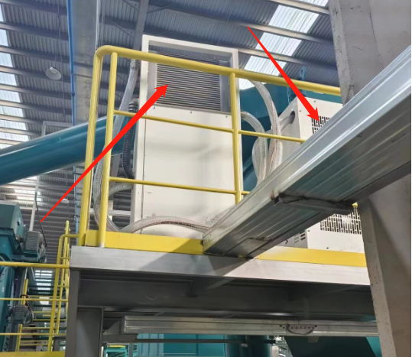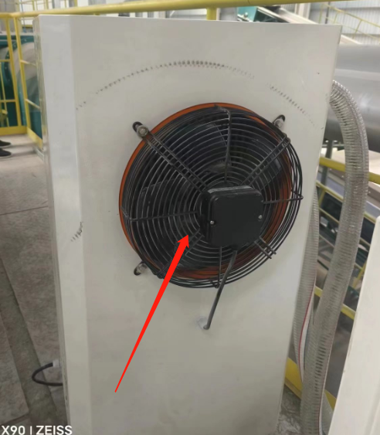
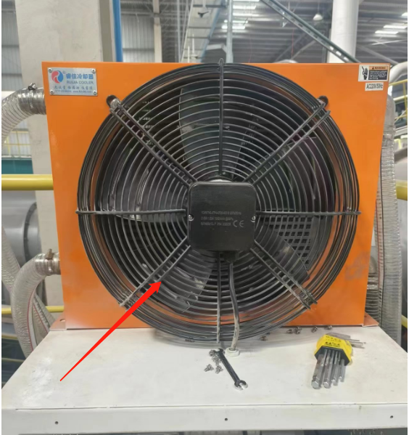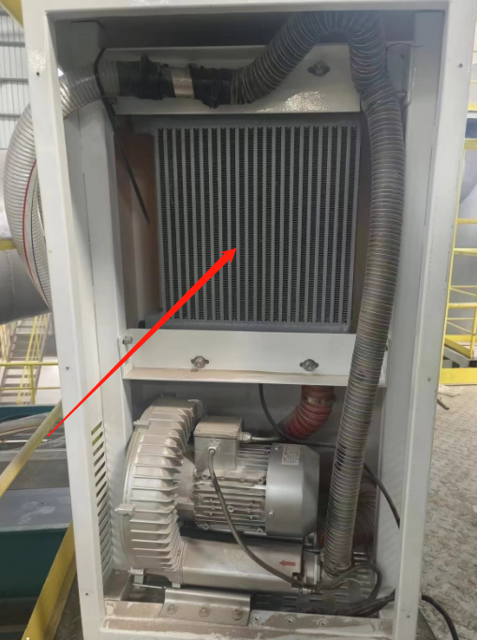
2. Dust removal in the purification box
The optical separator integrates an air purification box, which uses an exhaust fan to filter the dust from the natural wind and dissipate heat from the inside.
The purification box contains three filter cartridges, which are generally cleaned once every three to five working days depending on the air conditions on site.
The steps are as follows:
First of all, the four screws of the purification box are manually unscrewed to open the sealed door panel;
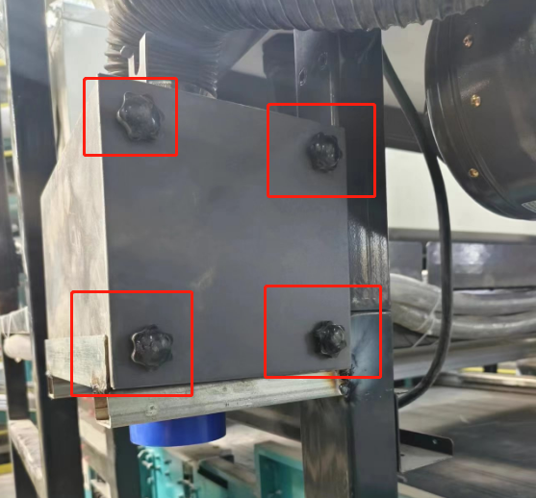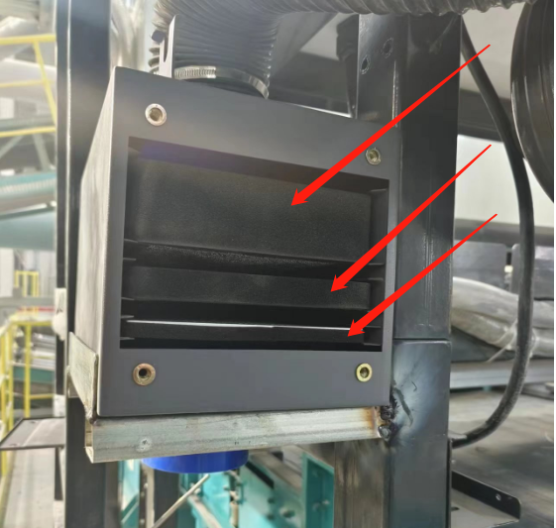
Take out the No. 1, 2 and 3 filter elements in turn, and use an air gun to remove the dust from the reverse side to ensure that the dust on the filter element is cleaned; after the dust removal is completed, insert the filter element back into the box in order and close the door tightly.
Secondly, check the status of the exhaust fan of the purification box, under normal circumstances, the exhaust fan will start to run, and you can feel the wind at the tuyere. If the air volume becomes small or there is no air, it is necessary to check whether the impeller of the exhaust fan is stuck.
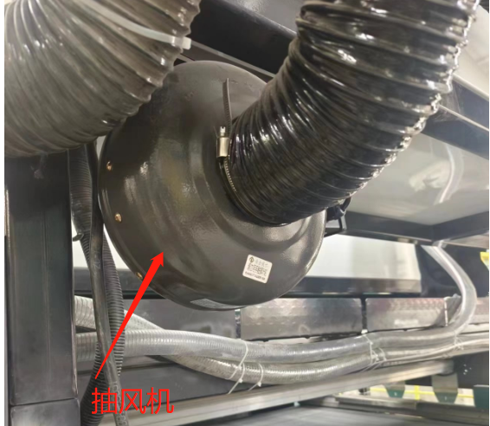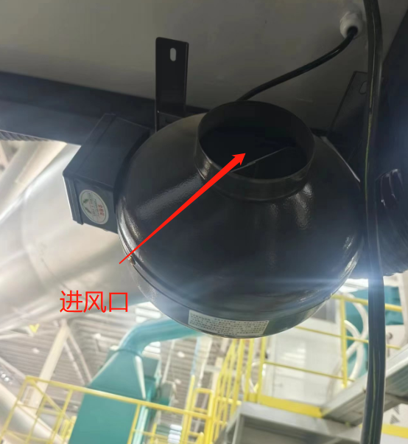

Second, the transmission device inspection

The belt bed is an important part of the optical separator system, which can provide the raw materials with a suitable movement speed for the system, too fast or too slow will affect the working effect of the sorter, and the deviation of the belt bed will also reduce the accuracy of sorting. Therefore, it is necessary to check the working condition of the belt bed regularly.
- Check that the material on the belt bed is evenly distributed
During the operation of the optical separator, if the materials on the belt bed are stacked or covered severely, it will affect the rejection efficiency of the spray valve. The belt bed needs to be inspected for wear defects or other problems in a timely manner.
- Check whether the belt bed is out of place
There are four groups of limiting wheels below the belt bed, if a certain one or a certain group of limiting wheels continue to rotate, it may be that the belt deviates, and manual intervention is needed to deal with it, and check whether the fixed position of each screw hole position has been displaced;
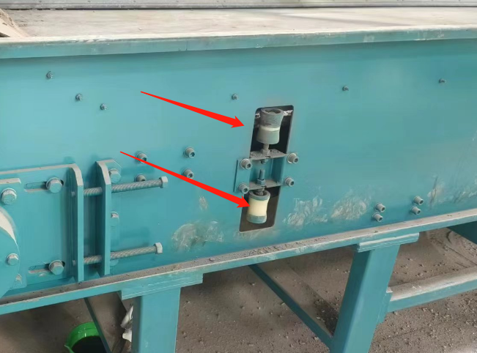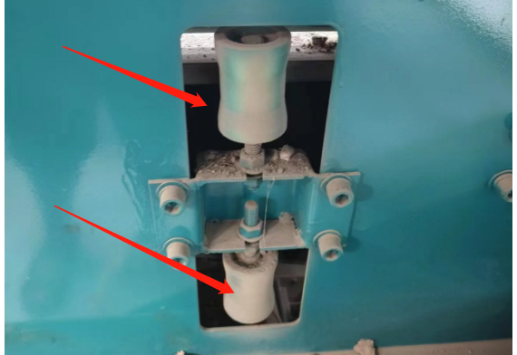
- Refill the bearing lubricant for the belt bed (once a month)
After a long period of operation, the lubricating oil inside the belt bed will gradually be consumed when the lubricating oil is consumed too much
At this time, the operation of the bearing will be affected, and the lubricating oil should be replenished in time to avoid bearing wear.
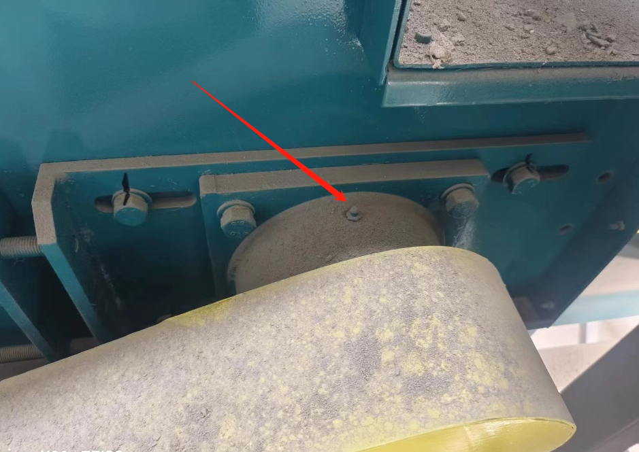
4. Check whether the fixing screws of the belt bed are offset (the position of the fixing screws has been marked with a black marker)
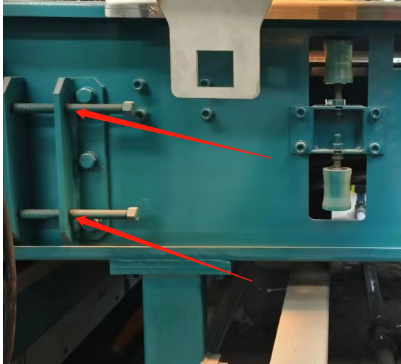

3. Check the window glass of the optical sorter
The high-speed camera of the optical sorter needs to ensure that there is a sufficiently stable light source when identifying materials. Because of the dust problem of the on-site environment, it is necessary to regularly check whether the glass of the infrared lamp source is stained or dusty, and if necessary, it can be wiped with an air gun or a moist paper towel, and the water needs to be wiped dry with a dry paper towel after wiping.
- Infrared light source inspection
Check that the outside of the transparent glass of the IR light source is clean, and if necessary, wipe it with an air gun or a moist paper towel. After wiping, you need to wipe the water dry with a dry paper towel
Note: The infrared light source may have residual temperature, operate with caution.
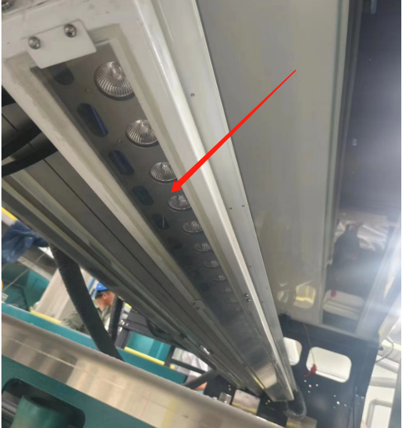
- Visible light source inspection
Check the visible light source glass for stains or dust, if necessary, you can wipe it with an air gun or a moist paper towel, and wipe it dry with a dry paper towel after wiping.
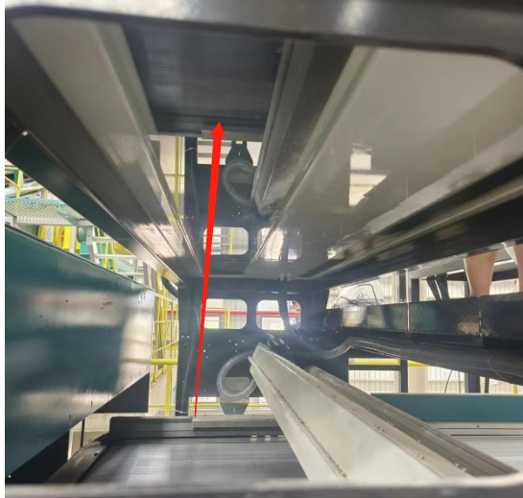

Fourth, high-speed spray valve inspection
In addition to ensuring that the position of the blowing valve can not be offset, it is also necessary to ensure that the air outlet of the blowing valve is clean to prevent fine dust from entering the valve body and affecting the rejection effect.
1. Check whether the fixed screws of the spray valves on the left and right sides have been offset, and the standard positions have been marked with a black marker.
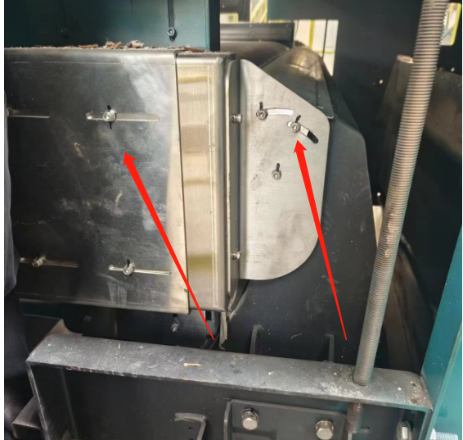
2. Check whether there is sticky debris at the outlet of the spray valve, and use an air gun to clean up the debris if necessary. It is necessary to pay attention not to use the air gun to clean directly at the gas outlet, as direct cleaning can easily cause dust to enter the inside of the valve body.
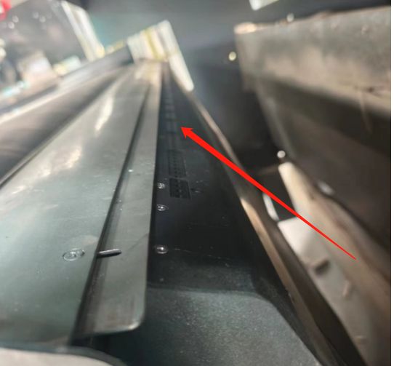
- Check whether the air pressure of the optical separator is stable and normal, and the stable and appropriate air pressure can ensure the accuracy of the spray valve.
The barometric pressure can be read from the barometer in the figure below. The normal range is around 6-6.5.
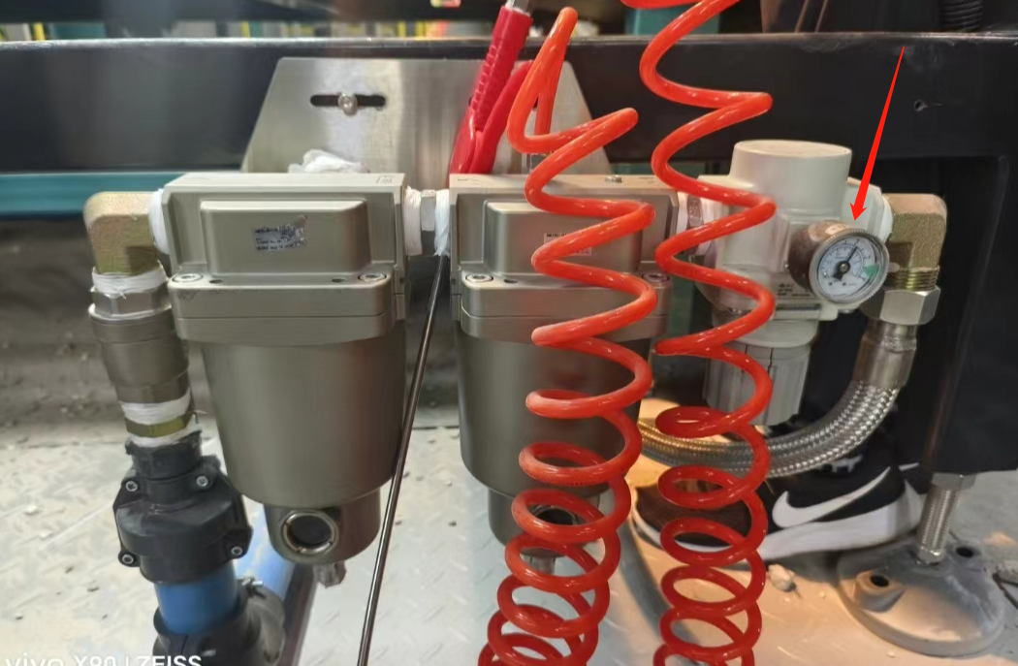

5. Parameter recovery
The parameters and scheme of the optical sorter have been set, under normal circumstances, the operator does not need to manually intervene the parameters on the touch screen, if there is a need to adjust the place, please contact the manufacturer's engineer for assistance.
If the parameters are changed by mistake, contact the manufacturer's engineer and use "Restore Parameters of the Whole Machine" to restore the parameters under the guidance of the manufacturer's engineer. Don't do it yourself!

